Since the flanger effect is like the vibrato effect but additionally has a direct path, as the figure :

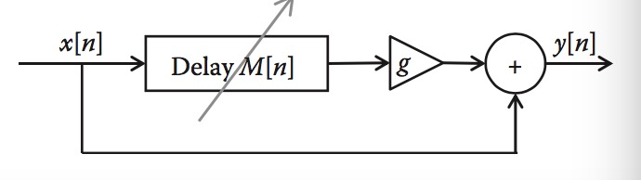

The input value was added to the output value additionally and the M delay had been given in the program.

Buffer was used to make a save and delay function.

Compare the original program, the exercise program sounds like compound of two channels, actually, it is sum of the wave after buffer and the original buffer.